**‘Game Changer’ Filmmakers Spend A Whopping Rs 75 Crores On Five Songs**

**Songs Stills (HD) :** https://we.tl/t-oqzNI0Xg6M

After the teaser of Global Star Ram Charan’s upcoming film Game Changer became an instant blockbuster with fans and audiences raving about it, the recent pre-release event in Dallas (USA) further hyped the film. The filmmakers have spent around Rs 75 crore on the songs. Picturesque locations, lavishness and grandeur in sets, stunning dance moves, vibrant music, aesthetic lyrics and production design make the songs of Game Changer a magnificent visual extravaganza.

**Major Highlights Of Songs**

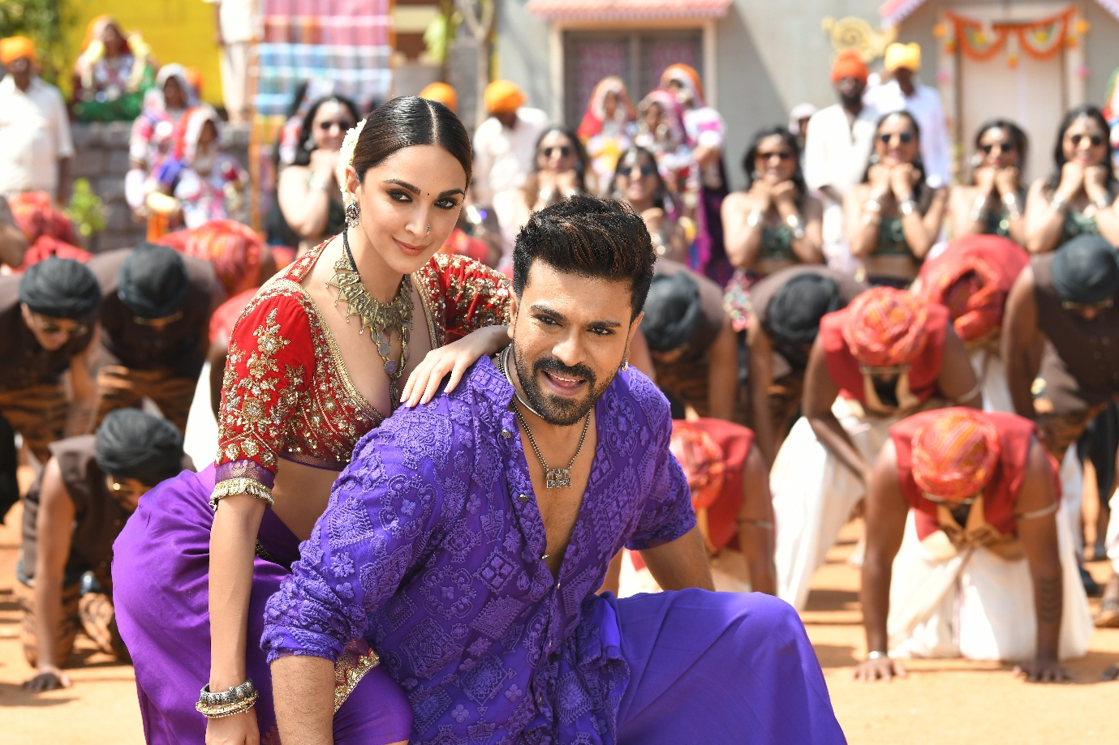

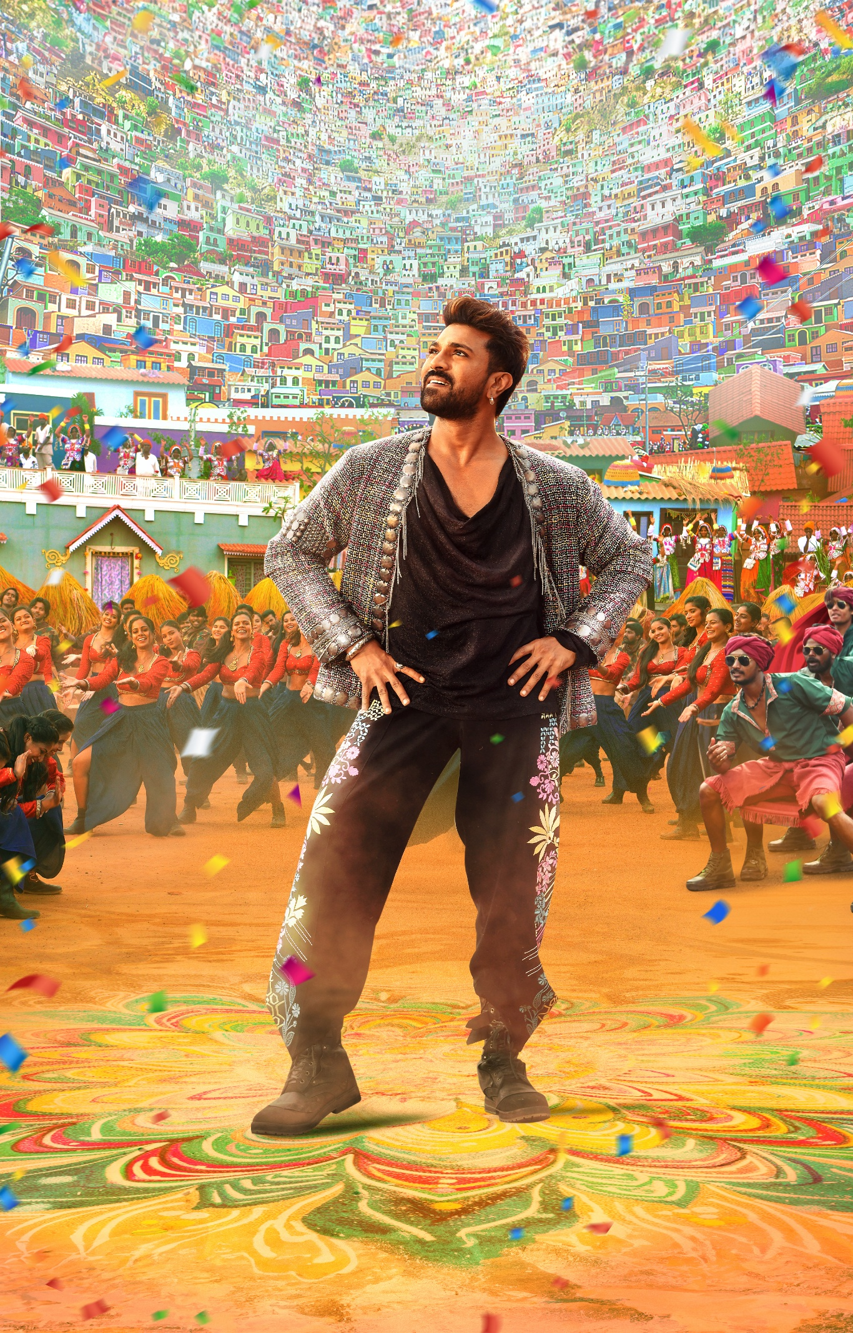

1. Jaragandi song was shot for over 13 days in a specially built 70 feet hill-village set. Shot with around 600 dancers for 8 days, Prabhu Dheva choreographed the dance moves. He worked ‘out of gratitude’ for director Shankar since the latter was the one who launched him as an actor. Interestingly, for the first time, eco-friendly costumes were used for the song designed by Ashwin-Rajesh. The material used in the costume was Jampanara (jute).

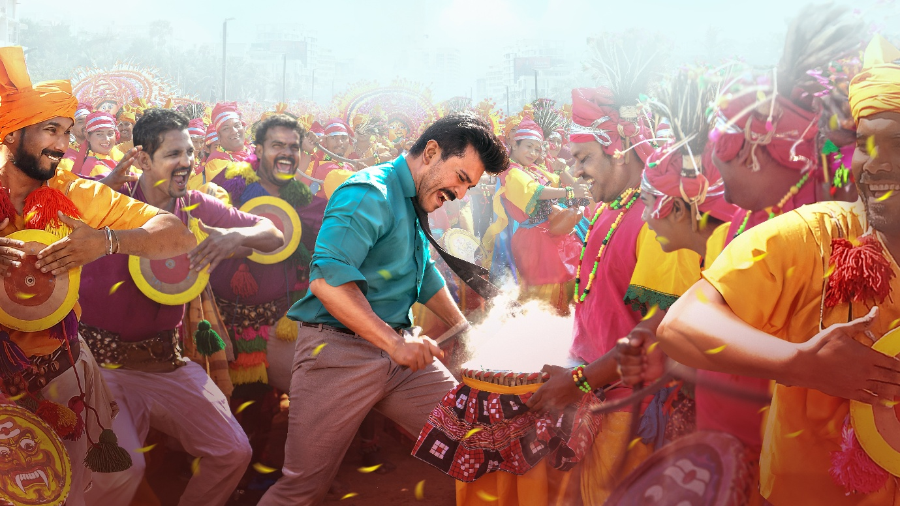

2. Ra Macha Macha is an introduction song of Ram Charan in the film choreographed by Ganesh Acharya. The song is a tribute to Indian dance forms & folklore art and features more than 1000 folk dancers alongside the actor. A tribute to India’s rich culture, the song showcases a wide array of folk dances from different regions including:

1) Gussadi – Adilabad; Kommu Koya and Tappeta Gullu (AP)

2) Chaau - West Bengal

3) Ghumra - Orissa - matilkala

4) Goravara - Kunitha(Karnataka)

5) Kummukoya - Srikakulam

6) Ranapa - Orissa

7) Paika - Jharkhand

8) Halakki - Vokkaliga - Karnataka.

9) Thapitha Gullu - Vijaynagaram

10) Durua - Orissa

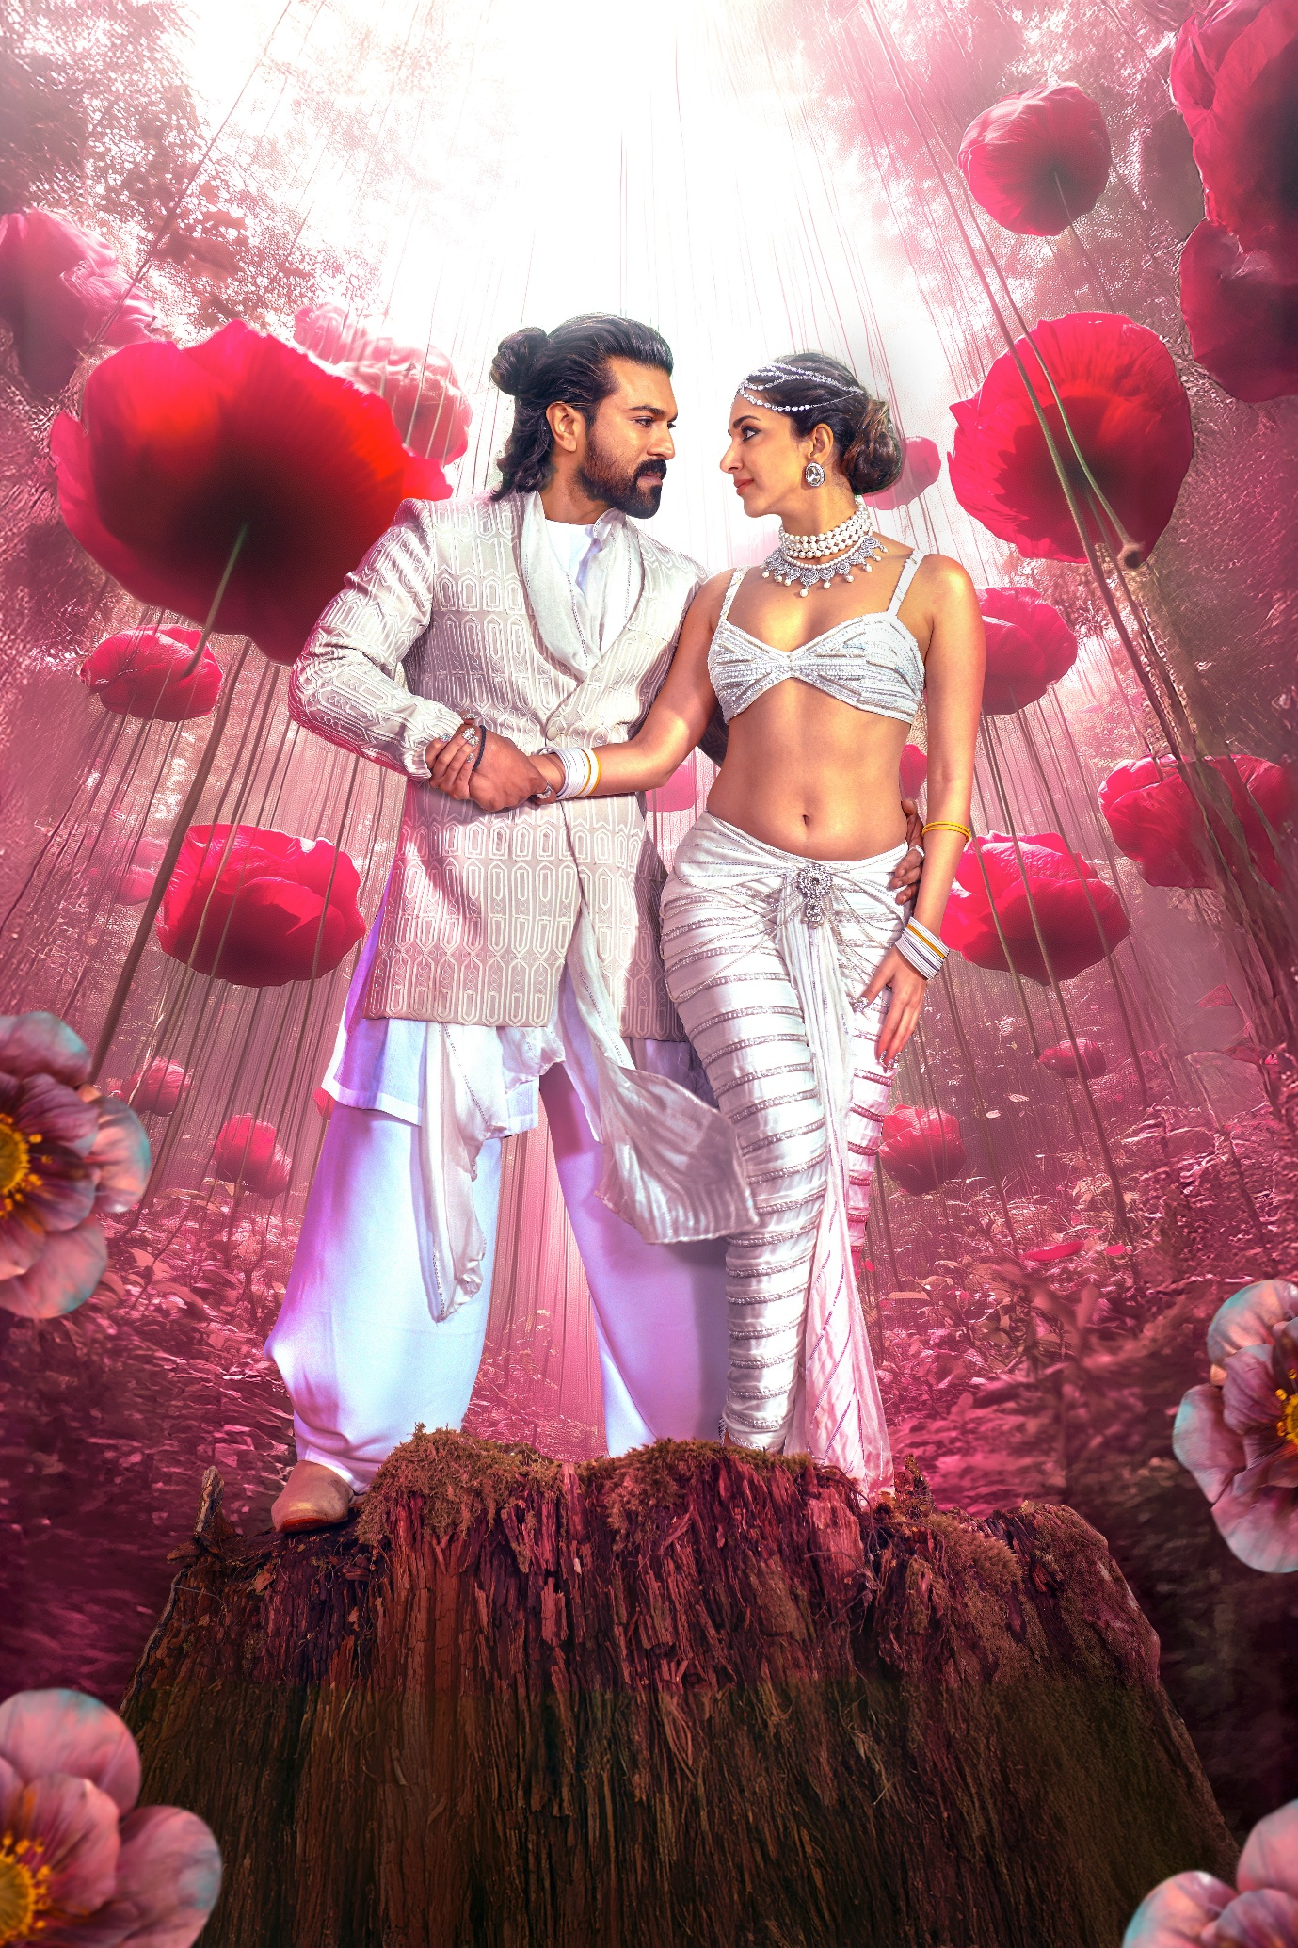

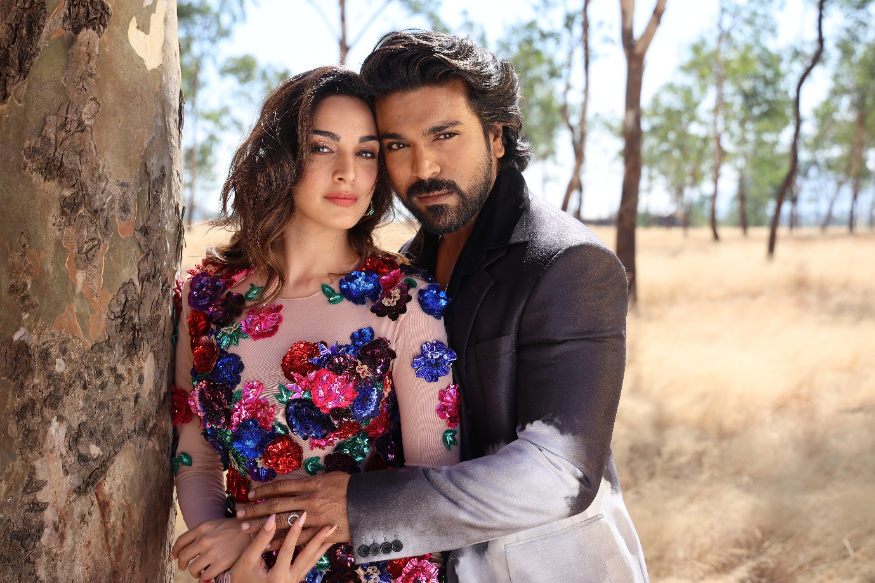

3. NaaNaaHyraanaa is the first Indian song to be shot on ‘infrared camera’ which has the ability to bring out various colours making it a dreamy sequence. The song, which was shot on Ram Charan and Kiara Advani in the picturesque locations in New Zealand, is a fusion of western and Carnatic sounds. It is described as the ‘melody of the year.’ Manish Malhotra designed the costumes for the song. Music composer Thaman came up with a unique programming idea to bring a different modality to create a unique sound with a lot of monotones. The song, which was shot in 6 days featuring several dancers from the country, beautifully captures the purity and innocence of intense love.

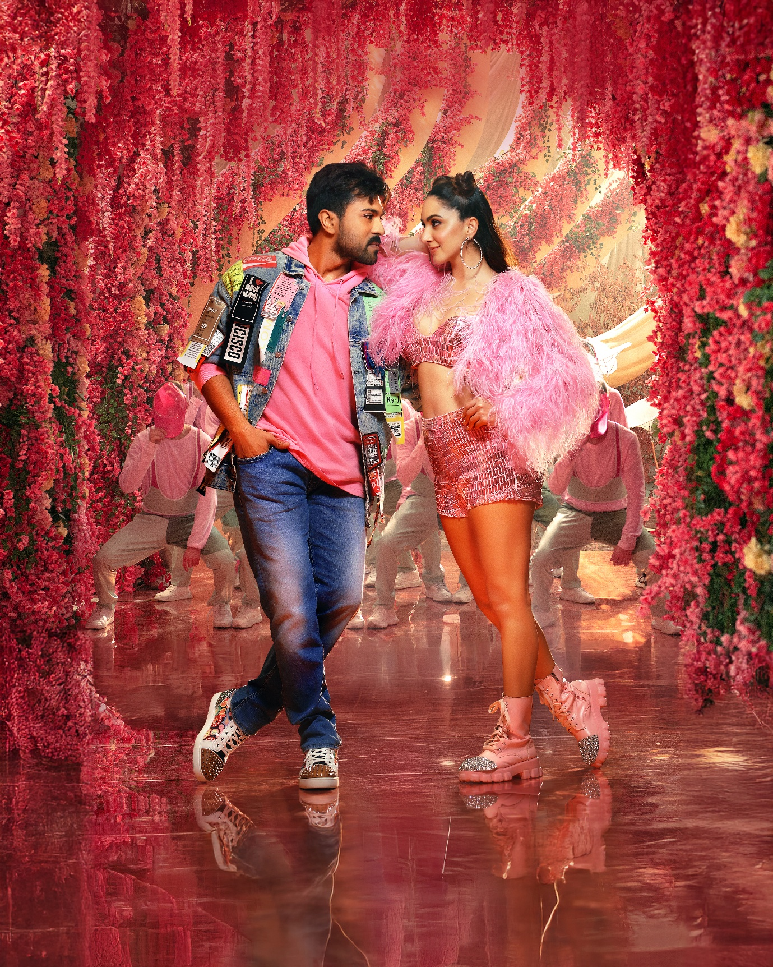

4. Dhop song is a techno dance number. It was shot during the covid second wave. Around ‘100 professional dancers’ were specially brought in from Russia in a special flight for the song which was shot lavishly for over 8 days in three different lavish sets in RFC. Manish Malhotra designed the costumes for the song. With catchy lyrics, and impressive choreography, the lyrical video of “Dhop” also has futuristic visuals. Ram Charan and Kiara Advani set the screen on fire with sizzling dance moves.

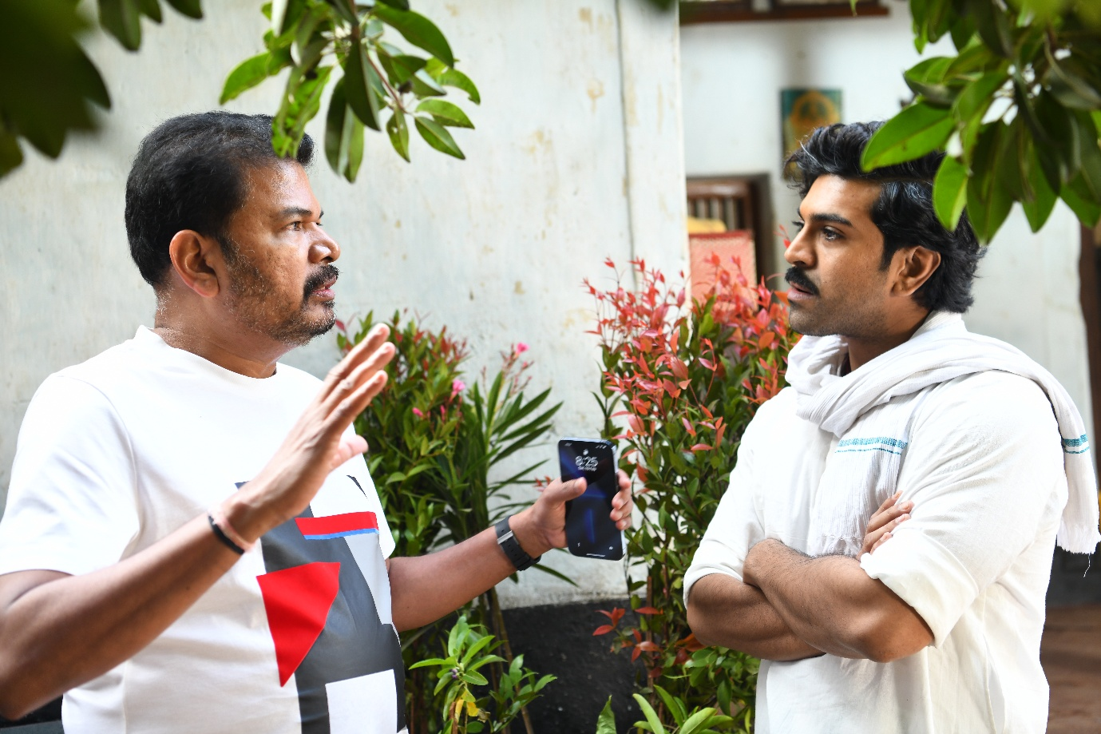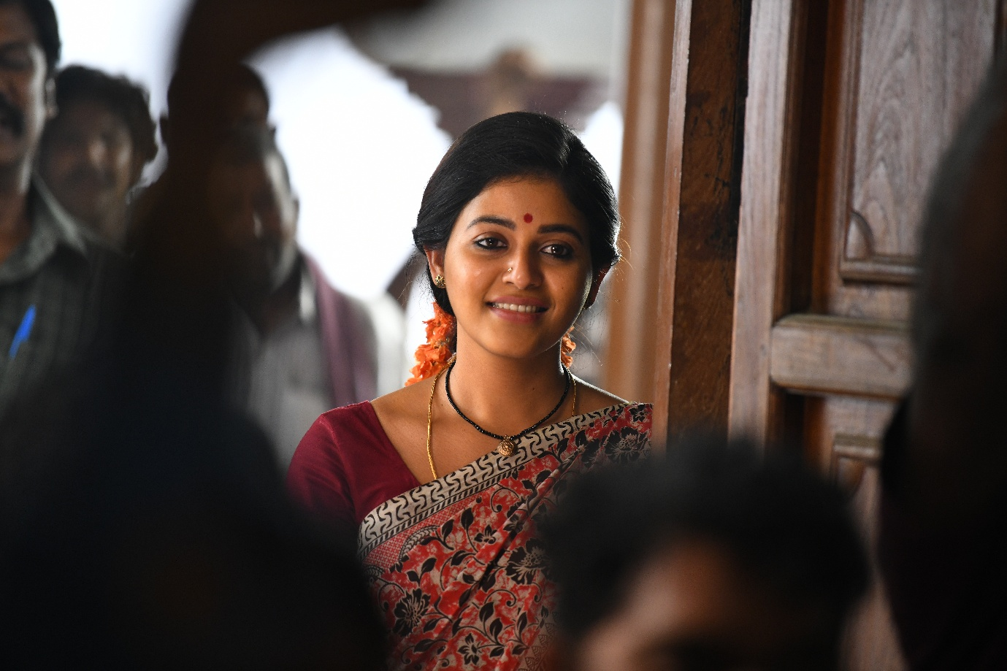

5. The 5th song is the surprise package – the filmmakers wanted the audiences to watch it on the silver screen and feel the thrill. The song was shot amid Godavari backdrop.

Game Changer is set for a grand release in Telugu, Tamil, and Hindi on January 10, 2025 as a Sankranti festival special.